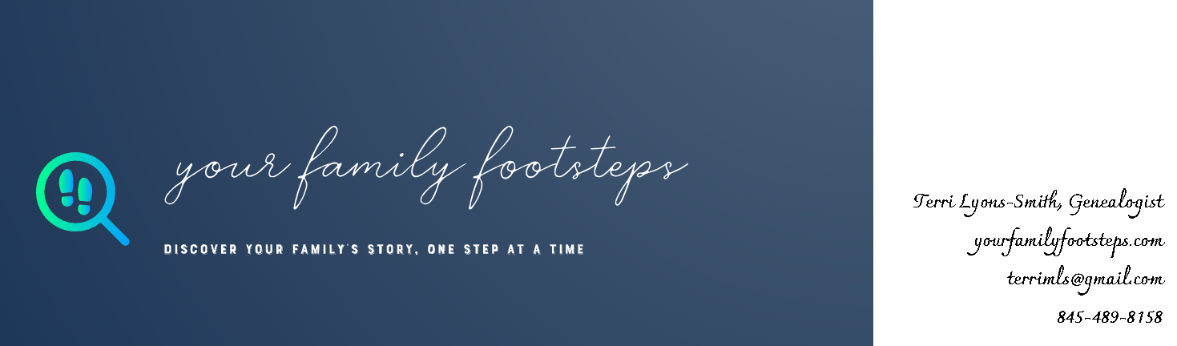

Objective :
Passionate and dedicated genealogist focused on preserving family legacies through exhaustive research and compelling storytelling. Specializing in tracing the history of 19th-century European immigrants to the United States, I combine traditional genealogical research methods with advanced DNA analysis to deliver accurate and detailed family histories. Seeking opportunities to leverage my expertise in records research, report writing, family history narratives, dual citizenship, and DNA analysis to help clients discover their family stories.

Professional Experience:

Genealogist: Your Family Footsteps, Hopewell Junction, New York, 2023-Present
- Research 19th-century European immigrants to the United States and their descendants there.
- Specialize in Western European research, focusing on the United Kingdom, Ireland, France, and Italy.
- Analyze traditional documentary records such as census, immigration, and vital records.
- Perform advanced DNA analysis to identify genetic connections and uncover family relationships.
- Provide dual citizenship assistance by locating records needed to prove citizenship.
- Specialize in New York Genealogy, with expertise in New York City Research.
- Produce well-written genealogical reports, narratives, and biographies.
- Restore and enhance old family photographs.

Researcher: ITCAM, Key Biscayne, Florida, March-April 2023
- Research Immigration and Naturalization records for clients seeking Italian dual citizenship.

Education:
- Graduate Studies in European History, Western Connecticut State University, 1992-1993
- BA in English, University of Connecticut

Certifications:
- Graduate ProGen64 – December 2023
- Graduate GenProof75 – April 2023
- Boston University Certificate in Genealogical Studies, May 2022
- National Genealogical Society, Certificate in American Genealogical Studies, December 2022
- PMI Certification, Project Management Institute 2007-Present

Skills:
- DNA Analysis
- Dual Citizenship Services
- Family History Narratives
- Immigration Stories
- New York Genealogy
- Old Photo Restoration
- Proofreading
- Research Writing and Editing
- Western European Research

Professional Memberships:
- Association of Professional Genealogists
- New York Genealogical and Biographical Society

References: Available upon request.

